**SUBINA K S**

[subinakandoth@gmail.com](mailto:subinakandoth@gmail.com)

www.linkedin.com/in/subina-ks-47145b153/

Kandoth(H),perinkary(p.o)

Kannur,kerala,India

9446395796

**EXPERIENCE**

Fresher

**PROJECTS**

1. Queston (online examination)

Language: jsp, mysql

2. NSS student management system.

Language: php , mysql

3. Online loan verification system

Language: .net,mysql

**MY LIFE PHILOSOPHY**

“Dreams do come to true, if we only wish hard enough.”

**TECHNICAL SKILLS**

C,C++,PHP,JSP,DBMS,JAVA

HTML5,JAVASCRIPT,.NET

**LANGUAGES**

English

Hindi

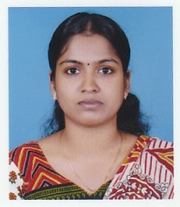

**EDUCATION**

BCA

kannur university

MCA

kannur university

**Additional Qualification:**

(ADCA)Advanced diploma in

computer application.

Software developer-

java (Training programme)

**MOST PROUD OF**

Secured many prizes in singing level competition.

NSS volunteer

Rajya puraskar certificate

**STRENGTHS**

Hard working

Dedicated

Honesty